**MATHEMATICS METHODS UNIT 1 TEST 1**

**CALCULATOR FREE NAME: ________________________**

**TIME ALLOWED: 20 MIN**

***Show all your working clearly.*** *Your working should be in sufficient detail to allow your answers to be checked readily and for marks to be awarded for reasoning. Incorrect answers given without supporting reasoning cannot be allocated any marks. For any question or part question worth more than two marks, valid working or justification is required to receive full marks. If you repeat any question, ensure that you cancel the answer you do not wish to have marked.*

**QUESTION 1**  **(2, 2 marks)**

For the line 

1. Sketch the line
2. Mark the angle of inclination the line makes with the axis. Determine this angle. Justify your answer.

**QUESTION 2**  **(1, 1 marks)**

Express the following in terms of angles between 0° and 90° and the state their exact value:

(a) cos120° (b) sin135°

**QUESTION 3**  **(4 marks)**

Find the exact value of expressed with a rational denominator.

**QUESTION 4**  **(2, 3 marks)**

1. Shown below are four rules and their corresponding graphs. For each, state whether or not it satisfies the conditions to be a function.
2.  Yes/No
3.  Yes/No
4.  Yes/No
5.  Yes/No

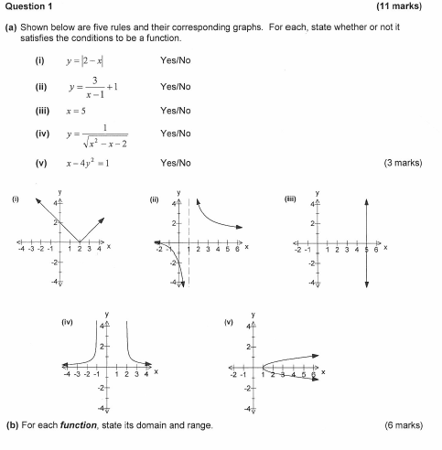

(i) (ii) (iii) (iv)

1. For each function, state its domain and range.

|  |  |  |
| --- | --- | --- |
| **RULE** | **DOMAIN** | **RANGE** |
|  |  |  |
|  |  |  |
|  |  |  |
|  |  |  |

**QUESTION 5**  **(3 marks)**

Simplify and express with a rational denominator: 

**QUESTION 6**  **(2 marks)**

Write 2550 as an angle in radians as a simplified fraction in terms of π

**QUESTION 7**  **(1 mark)**

A function is defined as . Write an expanded expression for 

**TOTAL MARKS: 21**